Indian School Al Wadi Al Kabir
SAMPLE PAPER 4 (2023-24)
INFORMATICS PRACTICES (Code: 065)
CLASS : XII Max. Marks:70
Time: 3 hours
General Instructions:
- This question paper contains five sections, Section A to E.
- All questions are compulsory.
- Section A have 18 questions carrying 01 mark each.
- Section B has 07 Very Short Answer type questions carrying 02 marks each.
- Section C has 05 Short Answer type questions carrying 03 marks each.
- Section D has 03 Long Answer type questions carrying 05 marks each.
- Section E has 02 questions carrying 04 marks each. One internal choice is given in Q35 against part c only.
- All programming questions are to be answered using Python Language only.

 | SECTION A
1 | Internet is an example of:  - LAN  - MAN  - WAN  - PAN | 1
2 | Which of the following is violation of IPR?  - Licensing  - Digital footprint  - Phishing  - Plagiarism | 1
3 | E-waste management in India is done as per guidelines of  - NITI Aayog  - Ministry of Commerce  - Central Pollution Control Board(CPCB)  - National Green Tribunal(NGT) | 1
4 | Which aggregation function does not give useful information when applied on non numeric attribute?  - Count  - Min  - Avg  - Max | 1
5 | after execution of given query. Select sum(name) from students;  - 0  - Error  - arun varun tarun  - None of above. | 1
6 | in GPL stands for:-  - Product  - Public  - Private  - Proprietry. | 1
7 | - SELECT DISTINCT COUNT(CITY) FROM BANK;  - SELECT COUNT(DISTINCT CITY) FROM BANK;  - SELECT DISTINCT COUNT(*) FROM BANK;  - SELECT COUNT(CITY) FROM BANK; | 1
8 | Which one of the following functions is used to find sum of numeric values of attributes?  - Sum()  - Total()  - Count()  - Avg() | 1
9 | - S.Head()  - S.head(10)  - S.Head(10)  - S.tail() | 1
10 | Which of the following statement will import dataframe from pandas library?  - import DataFrame from pandas  - from pandas import DataFrame  - import DataFrame from Pandas  - from Pandas import DataFrame | 1
11 | Which of the following is an aggregation function?  - ROUND()  - UCASE()  - NOW()  - SUM() | 1
12 | Which of the following functions is used to import a dataframe from csv file ?  - read_csv()  - import_csv()  - to_csv()  - export_csv() | 1
13 | What can be done from browser settings?  - Change home page  - Set default browser.  - Clear cookies  - All of the above | 1
14 | Which SQL function is used to display length of string values from attributes?  - Len()  - Length()  - Sum()  - None of the above | 1
15 | What will be considered as violation of IPR?  - Plagiarism  - Copyright Infringement  - Trademark Infringement  - All of the above | 1
16 | is the legal term to describe terms under which people are allowed to use the copyrighted material.  - Licensing  - Copyright  - Patent  - Trademark | 1
Q17 and 18 are ASSERTION AND REASONING based questions. Mark the correct choice as
- Both A and R are true and R is the correct explanation for A
- Both A and R are true and R is not the correct explanation for A
- A is True but R is False
- A is false but R is True
17 | ASSERTION: Websites keep track of users with the help of cookies. | 1
What is an IPR? G | REASON: Cookies are small text files that stores user information and send it to server when browser makes request again.
18 | ASSERTION: Data can easily be interpreted/visualised in python in form of line graph, bar graph and histograms.  REASON: To visualise data matlotlib.pyplot needs to be imported in python program | 1
 | SECTION B
19 | Write steps for hosting a website.  OR  Explain the types of network. | 2
20 | Madhu, a database administrator needs to display class wise maximum marks of all classes above 8th class. She is encountering an error in following query.  SELECT CLASS,MAX(MARKS) FROM STUDENT GROUP BY CLASS WHERE CLASS>8;  Help her in identifying error and write correct query by suggesting possible corrections. | 2
21 | What is purpose of GROUP BY clause in SQL. Explain with suitable example. | 2
22 | Write a program to create a series using numpy array that stores capitals of some  countries. Give appropriate index while creating series. | 2
23 | Discuss e-waste management strategies. OR  What is an IPR? Give examples of IPR? | 2
24 | What will be the output of following code:  import pandas as pd s=pd.Series({1:1,2:4,3:9,4:16})  print(s[s%2==0]) | 2
25 | Carefully observe the following code:  import pandas as pd  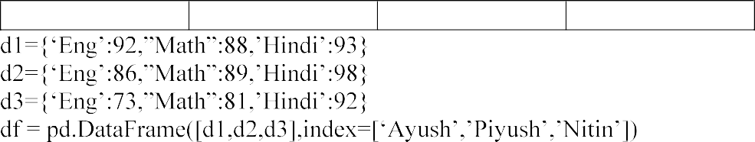  Nitin 73 81 92  Eng Math Hindi  Ayush 92 88 93  Piyush 86 89 98  print(df)  - List the column names of dataframe df.  - List the index name of dataframe df. | 2
 | SECTION C
26 | Write outputs for SQL queries (i) to (iii) which are based on the given table BANK:  ACCNO ANAME CITY BALANCE LASTUPDATEDON  101011 Ramesh Jammu 1000.67 2022-11-06  101316 Suresh Srinagar 9025.76 2022-11-01  101512 Mehak Delhi 8053.43 2022-11-06  101011 Kashish Jammu 7061.55 2022-10-10  - SELECT SUBSTR(ACCNO,3,2), CITY FROM BANK WHERE BALANCE>5000;  - SELECT ROUND(BALANCE,1),ANAME FROM BANK WHERE LENGTH(ANAME)>5;  - SELECT YEAR(LASTUPDATEDON), ACCNO FROM BANK WHERE BALANCE>1000; | 3
27 | Write python code to create a dataframe df (runs scored by batsman in last three  years) with appropriate row labels from the dictionary given below: | 3

 | Year | State | Population
0 | 2017 | Punjab | 10.5
1 | 2018 | HP | 10.3
2 | 2019 | Rajasthan | 11.5
3 | 2020 | Gujrat | 10.8

RollNo | Name | Class | Gender | Height | Weight
1 | Amit | XI | M | 168 | 72
2 | Ashok | XII | M | 169 | 71
3 | Arun | X | M | 163 | 70
4 | Diksha | XII | F | 159 | 61
5 | Akanksha | XI | F | 156 | 60
6 | Sita | XI | F | 162 | 63
7 | Gita | XI | F | 157 | 58
8 | Ram | X | M | 159 | 59

28 | Consider the given dataframe df:  4 2021 Haryana 10.9  (i)  - Add new state MP with population 10.5  - Remove the column debt. |  |  |  | 3
29 | Priya has received an SMS on mobile, asking her to provide the details of her old debit card in order to get new one. She clicked on the link in the message and entered the details of her debit card assuming that this message was from her bank.  - Which cyber crime happened with her?  - What immediate action should she take to handle it?  - Is there any law in India to handle such issues. Discuss briefly. OR  What are cyber crimes? Name a few cyber crimes and is there any law in India which guards its citizens against cyber crimes? |  |  |  | 3
30 | Based on the table STUDENT given here, write suitable SQL queries for the following:  - Display total number of male and female students.  - Display gender wise minimum weight.  - Display class wise tallest student OR  What are aggregation functions? Name all the aggregation functions. Write examples for all the aggregation functions. |  |  |  | 3
 | SECTION D
31 | Write suitable SQL query for the following:  - Display 3 characters extracted from the 5th left character from string  - Round off the value 23.52 to zero decimal place.  - Display the remainder of 50 divided by 3.  - Remove all the expected leading spaces from  OR  Explain the following SQL functions using suitable examples:  - LCASE()  - TRIM()  - INSTR()  - MONTHNAME()  - MOD() |  |  |  | 5

HR Block to Accounts Block | 400m
Accounts Block to Logistics Block | 200m
Logistics Block to HR Block | 150m
Delhi Head Office to Chandigarh Office | 270 km

HR Block | 70
Accounts Block | 50
Logistics Block | 40

32 | Hi Speed Technologies Ltd. is a Delhi based organisation which is expanding its office setup to Chandigarh. At Chandigarh office they are planning to have 3 different blocks for HR, Accounts and Logistics related work. Each block has number of computers which are required to be connected in a network for communication, data and resource sharing.  Delhi Chandigarh Office  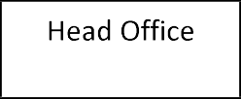  As a network consultant, you have to suggest the best network related solutions for them for issues/problems raised in (i) to (v), keeping in mind the distances between various blocks/locations and other given parameters.  Shortest distances between various blocks/locations:  Number of computers installed at various blocks are as follows:  - Suggest the most appropriate block/location to house the server in the Chandigarh office(out of the three blocks) to get the best and effective connectivity. Justify your answer.  - Suggest the cable layout to efficiently connect various blocks with in Chandigarh office.  - Suggest the network device to use within various blocks to connect computers.  - Suggest a device/software and its placement that would provide data security for the entire network of Chandigarh office.  - Which of the network type, would it be? | 5
33 | Write python code to plot a bar chart for Library Books as shown below:  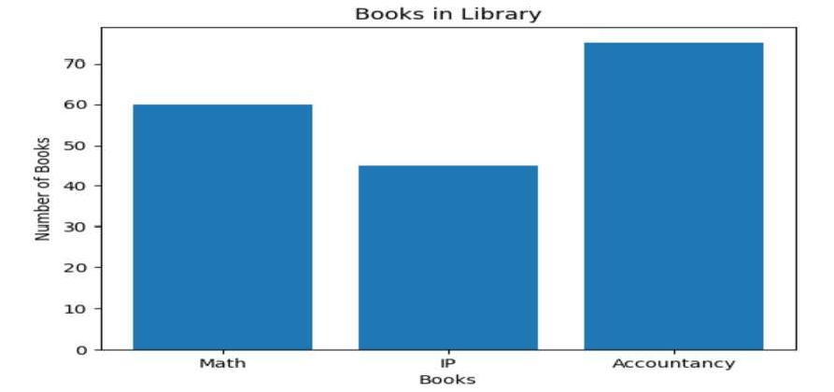  Also give suitable python statement to save this chart. OR | 5

InvoiceNo | CarId | CustId | SaleDate | PaymentMode | EmpId | SalePrice
101 | D01 | C01 | 2019-01-  24 | Credit Card | E04 | 613247.00
102 | S01 | C02 | 2018-12-  12 | Online | E01 | 590321.00
103 | S02 | C04 | 2019-01-  25 | Cheque | E10 | 604000.00
104 | D01 | C01 | 2018-10-  15 | Bank Finance | E07 | 659982.00
105 | E01 | C03 | 2018-12-  20 | Credit Card | E02 | 369310.00

Write a program to plot a line chart based on the given data to depict the runs scored by a batsman in 5 innings.
Innings = [1,2,3,4,5]
Runs = [102,88,98,146,52]
 | SECTION E
34 | Pallavi, a database administrator has designed a database for cars showroom. Help her by writing answers to the following questions based on the given table:  SALE  - Write a query to display invoice number and name of month in which car is purchased.  - Write a query to display highest price .  - Write query to display all the information in descending order of sale price. OR(for part iii only)  Write query to display the number of cars purchased through each payment method. | 1+1+2
35 | Mr. Ajay, a data analyst has designed a dataframe df that contain data about marks obtained by students in different subjects. Answer the following questions:  Accountancy Economics IP  Ayush 92 82 72  Karan 87 89 87  Tarun 95 88 97  - Predict output of following python statement:  - df.shape  - df[1:]  - Write python statement to display the marks of ayush and tarun.  OR(for part (b) only)  Write python statement to compute the sum of marks of all the subjects of given dataframe and add it as another column. | 1+1+2

